Contestant Number:
Time:
Rank:


Fundamentals of Web Design
(405)

STATE 2020

Multiple Choice (20 @ 10 points each) (200 points)

Application (285 points)

TOTAL POINTS (485 points)
Failure to adhere to any of the following rules will result in disqualification:
- Contestant must hand in this test booklet and all printouts. Failure to do so will result in disqualification.
- No equipment, supplies, or materials other than those specified for this event are allowed in the testing area. No previous BPA tests and/or sample tests or facsimile (handwritten, photocopied, or keyed) are allowed in the testing area.
- Electronic devices will be monitored according to ACT standards.

No more than ten (10) minutes orientation
No more than ninety (90) minutes testing time
No more than ten (10) minutes wrap-up
Property of Business Professionals of America.
May be reproduced only for use in the Business Professionals of America
Workplace Skills Assessment Program competition.

MULTIPLE CHOICE
Identify the letter of the choice that best completes the statement or answers the question.

- What is the correct HTML for creating a hyperlink?
  - <a href=“http://www.google.com”>Google</a>
  - <a name=“http://www.google.com”>Google</a>
  - <a>http://www.google.com</a>
  - <a url=“http://www.google.com”><Google</a>

- What type of tags are preformatted to help organize page content within an HTML document?
  - Preformatted tags
  - Formatted tags
  - Sinister Tags
  - Semantic Tags

- What is the purpose for !important in CSS?
  - It is used to tell the individuals on the website what is important
  - This style is not used in CSS
  - Makes the particular to have the highest specificity possible
  - Adds animation to text

- What does FTP stand for?
  - File Transfer Procedure
  - File Transcript Protocol
  - File Transcript Procedure
  - File Transfer Protocol

- A(n)______________ is used in syndication that could be used as a side bar for a website. This could be used to hold navigation list, email subscription, or additional links
  - Article Element
  - Aside Element
  - Summary Element
  - Section Element

- Which tag is used to help create/build charts, graphs, bypass Photoshop to create 2D images and place them directly into HTML5 code?
  - <iframe>
  - <canvas>
  - <chart>
  - <graphs>

- What is the difference between a div tag and a span tag?
  - A div tag gives the output with display:inline, while span gives the output display:block
  - A span tag gives the output with display:inline, while div gives the output display:block
  - There is no difference between a div and span tag
  - The span tag is no longer used in HTML5 while the div tag still is

- Which of these elements are all <table> elements?
  - <thead><body><tr>
  - <table><tr><td>
  - <table><head><tfoot>
  - <table><td><tt>

- What is the correct HTML for inserting a background image?
  - <background img=”background.gif”>
  - <body style=“background-image:url(background.gif)”>
  - <body bg style=“background-image:url(background.gif)”>
  - <body bg=“background.gif”>

- How can you open a link in a new tab/browser window?
  - <a href=“url” target=”new”>
  - <a href=“url” new>
  - <a href=“url” _blank>
  - <a href=url” target=”_blank”>

- How would you create a radial gradient for a background using the colors white, rgb(151, 222, 151), rgb(81, 125,81)?
  - background: radial-gradient(white, rgb(151, 222, 151), rgb(81, 125,81))
  - background: radial-gradient-center(white), radial-gradient-middle(rgb(151,222,151)), radial-gradient-outside(rgb(81, 125,81))
  - background-color: radial-gradient(white, rgb(151, 222, 151), rgb(81, 125,81))
  - background-color: radial-gradient-center(white), radial-gradient-middle(rgb(151,222,151)), radial-gradient-outside(rgb(81, 125,81))
- Which type of layout is used to determine the properties of the device rendering the page so that appropriate designs can be delivered to specific devices?
  - Flexible layout
  - Responsive Queries
  - Media Layout
  - Media Queries

- Many companies and web servers use FTP sites for what reason?
  - FTP sites have a list of current HTML and CSS standards
  - FTP Sites allow users to be anonymous
  - FTP sites allow users to upload and download files simultaneously and quickly
  - FTP sites allow you to get to other websites while offline.

- If you would want to change the color of a link once it has been visited by the user, which element would you use?
  - a:visited
  - a:visit
  - a:passive
  - a:active

- What is the difference between separate borders and collapsed borders?
  - Collapsed borders have separate lines for each cell creating two lines with white space in between, while Separate borders combine the borders of each individual cell together for one line.
  - Separate borders have separate lines for each cell creating two lines with white space in between, while collapsed borders combine the borders of each individual cell together for one line.
  - Separate borders makes the border hidden, while collapsed border shows the borders between all the cells
  - Collapsed borders makes the border bidden, while separate border shows the borders between all the cells

- When you want to combine multiple rows together to create a merged cell affect, you would use which tag?
  - colspan
  - cellspan
  - rowspan
  - Headingspan

- What is the maximum size in the media query for mobile screen widths?
  - 360px
  - 480px
  - 768px
  - 0px

- What colors should be avoided for key content to an audience with color blindness?
  - red and green
  - red and yellow
  - blue and yellow
  - gray and purple

- What is the advantage of used an Integrated Development Environment (IDE) to create a website?
  - An IDE includes tools to write and debug code in any language
  - An IDE allows for automatic uploading to a server
  - An IDE can resize a video for your website
  - An IDE can be used as a database

- The protocol ensures every connected device on Earth will always have a unique IP address?
  - UDP
  - TCP/IP
  - IPv4
  - IPv6

Applications

You have been asked to create a website for a small company called “Russo’s Pizzeria”. You are going to create a three-page website for the company; first page just giving information about the company, the second page organized as a menu, and the third page to order the pizza. In this application, you will be working on the first page of the website - an informative page.

During this exercise, you are only allowed to use Notepad. The use of any other type of text editor such as Notepad++ or for web development tools such as Dreamweaver or Expression Web will result in immediate disqualification from this event.

A screen capture of the expected end result is included for your inspection and to be used as a guide for completing this exercise.

When complete, print all code generated for this exercise (HTML and Style Sheet). Also print a screen capture of your finished work as it appears in the web browser so that it may be used for grading purposes.

Submit all printed pages, along with your copy of this test, and your answer form to your proctor.

Your task is to regenerate the web page shown in the screen capture provided in this packet, using HTML5, CSS, and the parameters specified below.

- Overall Specifications
  - The document must be valid HTML5
  - The documents must be styled with an external cascading style sheet
    - ALL styles must be done with the style sheet. Using tags or style attributes within tags is PROHIBITED
  - Expect for the restaurant’s’ menu, the document must not use tables for any sort of layout or positioning

- General Pages Specifications
  - Title should have Your constant number - Fundamentals of Web Design
  - Create a CSS file, stylesheets.css, create a comment in the CSS that says the following “Table Styles”.
  - Create a border-collapse set to collapse style to the Table
  - Create a border style for the table, tr, th, and td. Use the following style properties:
    - Set the border to 5 pixels
    - Set the border style to inset
    - Set the border color to #800000
  - Style the class called title to the following style properties:
    - Set the text to center
    - set the background color to black
    - Set the font color to white
    - Set the font size to 14 points
  - Style the class called green to the following properties:
    - Set the background color to rgb(34, 139, 34)
  - Set the caption to the font-size to 10 points
  - Style the body to the following properties:
    - Background color is rgb (128, 0, 0)
    - Text Color #000000
    - The default font for page body needs to be ‘Times New Roman” with a fall back on “times” and another fall back on “serif”
  - Create a container using an ID that will hold all the information on the page. Use the following properties for the style on the page:
    - Background color: #FFFFFF
    - Width: 80 percent
    - Margins: top and bottom to 0 pixels and left and right to auto
    - Padding: 25 pixels
  - Use a navigation tag to apply properties to the hyperlinks for the web page:
    - text align set to center
  - Use the pseudo tags to add animation to the links. Use the following properties:
    - Set the default link to Black using the correct pseudo tag
    - Set hover effect of the link:
      - Set the font color to white
      - Set the background color red
  - Use a navigation tag to apply properties to the hyperlinks for the web page:
    - text align set to center
  - Images must have the following style properties
    - Set the display to a block
    - Set the width of the image to 40 percent
    - Margins: top and bottom to 0 pixels and left and right to auto
  - Use the pseudo tags to add animation to the links. Use the following properties:
    - Set the default link to Black using the correct pseudo tag
    - Set hover effect of the link:
      - Set the font color to white
      - Set the background color red

- Page Content
  - Between the opening and closing body tags, insert a div tag with the id attribute for the container style. Note, all following HTML elements will be nested inside of this “container” div element.
  - Place the Russo’s Pizzeria Logo and make sure that it is centered
    - Give the alternate text “Russo Pizzeria logo”
  - Create a navigation bar - Center (Make sure that the home Link links to the index file given to you)
    - Home | (Use the file name ‘index.html’)
    - Menu | (Use the file name ‘menu.html’)
    - Order (Use the file name ‘order.html’)
  - Create a horizontal Rule after the navigation
  - OUR MENU - h2
  - Create a Table to hold the following menu information using the correct Table headings, Table row tags, and table data tags. (Use comments, if necessary, to organize the table)
  - Create a caption with the following text “**Green are vegetarian option”
  - In the first row, create three table headings:
    - Pizza
    - Description
    - Price
  - In the second row, give this row a class called Title.
    - Have the table data span over three columns and have the data say “Specialty Pizzas”
  - In the third, create three cells of data.
    - Bacon Chicken Ranch Pizza
    - A common specialty pizza made with the Russo Family Twist. The Bacon Chicken Ranch pizza is made with fresh dough. A shredded chicken, ranching dressing mix is placed on top of the pizza dough as a sauce. We cover the top of the pizza with Russo's favorites, crispy bacon, sliced green onions, diced tomatoes, chopped celery, and red peppers. The pizza is then topped with a cheese mixture including, mozzarella, cheddar cheese, and Colby.
    - $14.00
  - In the fourth row, Create three cells of data,
    - Bacon Spinach Tomato
    - Our Bacon-Spinach-Tomato pizza takes your traditional bacon lettuce and tomato sandwich and turns it into a unique and delicious pizza. The freshly made pizza dough is covered with our white cream sauce, topped with crispy bacon, spinach, and large tomato slices. Parmesan and Asiago cheese sprinkled on top and cooked to perfection.
    - Set the row span to cover 3 rows and type the following: $12.00
  - In the fifth row, create two cells of data:
    - Blue Cheese Prosciutto
    - The Blue Cheese Prosciutto Pizza is the main pizza that has been passed through the Russo family before the business even started. The Blue Cheese pizza started in Venice and made it over to the United States, when the family migrated. The freshly-made pizza dough is topped off with the family secret tomato sauce, mozzarella cheese, blue cheese crumbles, and prosciutto. The pizza is baked until crispy and fluffy.
  - In the sixth row, make the sixth row a class called “green” and create two cells of data:
    - Greek Pizza
    - Here is a chance to try your favorite salad as a pizza. The Greek Pizza is made with freshly-made whole wheat dough and seasoned, whole-crushed tomatoes sauce. The sauce is topped with spinach, sliced red onions, halved Kalamata olives, sliced red peppers, feta cheese, and mozzarella cheese. After the pizza is cooked to perfection, our family-secret Greek dressing is drizzled on top for that extra Greek salad flavor
  - In the seventh row, make the Seventh row a class called “green” and create three cells of data:
    - Margherita Pizza
    - Our Margherita pizza is made with fresh ingredients from beginning to end. The Homemade dough is topped with our family secret Pesto sauce, slices of fresh Roma tomatoes, black olives, and large slices of Mozzarella cheese melted to a bubbly perfection.
    - $10.00
  - In the seventh row, make the Seventh row a class called “green” and create three cells of data:
    - Mediterranean Pizza
    - Our Number one choice of specialty pizza, according to our customers is the refreshing Mediterranean Pizza. Similar to the Margherita pizza, the Mediterranean pizza uses our house specialty pesto sauce. Topped with sun-dried tomatoes, artichoke hearts, grilled chicken breasts, kalamata olives, mushrooms, red onions, goat cheese, feta cheese, basil leaves, spinach, and shredded mozzarella cheese.
    - $14.00
  - (Make sure that the two rows with the class green show green on your screen)
  - Close your table and make sure that your data looks similar to the sample given to you.
  - Create a Horizontal Rule after the table
  - Create a new paragraph
    - Use the Copyright symbol code
    - 2019 Russo’s Pizzeria. All rights reserved.
When finished creating the website, print the code and the screen capture of the browser page.
Turn in all printouts and your testing instructions to your proctor.

Sample:

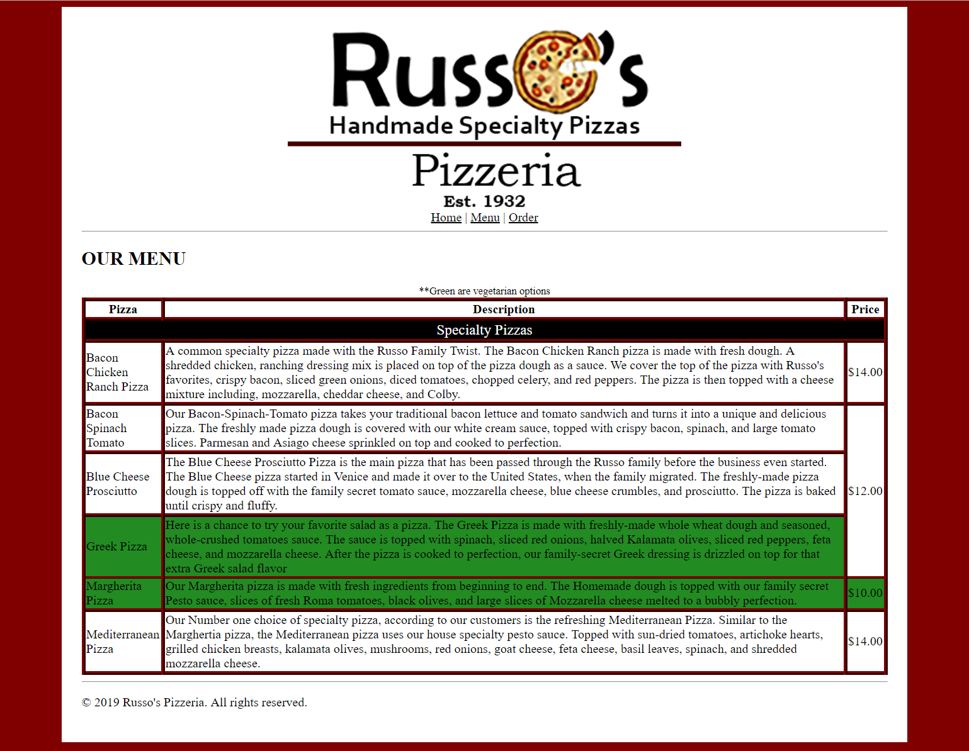
APPLICATION RUBRIC

HTML | Point Value | Score
Correct DOCTYPE declaration | 5
Set the HTML document to English | 5
<head> tag properly placed and used | 5
<title> tag includes contestants BPA membership number | 10
<link> tag reference to a CSS stylesheet | 10
Use HTML comment tags to help organize the table and information | 10
<body> tag has no properties | 5
Place Russo’s Logo image “russoLogo.png” and have the image centered with the correct alternate text | 5
<nav> tag and create a navigation bar using the correct file names | 10
<hr> used under the navigation menu and the before the copyright statement | 10
<h2> tags have the correct heading titles - all in caps | 20
Have all the text for the table data tags have no mistakes or misspellings - 5 points taken off for misspellings | 30
Create the table that displays a border to organize data. Use the correct tags such as table row, table headings, and table data for the information. | 15
Use the <caption> tag to display the information above the table. | 15
&copy; Russo’s Pizzeria. All Rights reserved. In the footer | 5
HTML TOTAL | 160

CSS | Point Value | Score
Style Sheet is external: (Can be called anything) | 10
Create a CSS comment for Table Styles | 5
table { border-collapse: collapse | 5
table, tr, th, td { border: 5px inset #800000 | 5
.title { text-align: center | 5
.title { background-color: black | 5
.title {color: white; | 5
.title { font-size: 14pt | 5
.green { background-color: rgb(34,139,34) | 5
caption { font-size: 10pt | 5
body { background-color: rgb (128, 0, 0) | 5
body { color: #0000000 | 5
body { font-family: ‘Times New Roman’, Times, serif | 5
#container { background-color: #FFFFFF | 5
#container { width: 80% | 5
#container { margin: 0 auto | 5
#container { padding: 25 px | 5
a:link { color: black | 5
a:hover { color: white | 5
a:hover { background-color: red; | 5
nav { text-align: center | 5
img { width: 500 px | 5
img { margin: 0px auto | 5
img { display: block | 5
CSS TOTAL | 125
FORMATTING | Point value | Score
Deduct 5 points for each discrepancy, up to 15 points | 15
Application Total | 285
Objective Total (from page 2)
EVENT TOTAL

